**Introduction to HTML Forms and CSS Basics**

**LAB # 09**



**Spring 2022**

**Computer Fundamental**

Submitted by: **Muhammad Sadeeq**

Registration No : **21PWCSE2028**

Class Section: **C**

“On my honor, as student of University of Engineering and Technology, I have neither given nor received unauthorized assistance on this academic work.”

Student Signature: *Muhammad**Sadeeq*

Submitted to:

**Engr. Abdullah Hamid**

(13-March-2022)

Department of Computer Systems Engineering

University of Engineering and Technology, Peshawar

Lab 9:

Introduction to HTML Forms and CSS Basics

Lab Tasks:

Make a webpage according to the diagram in the image below

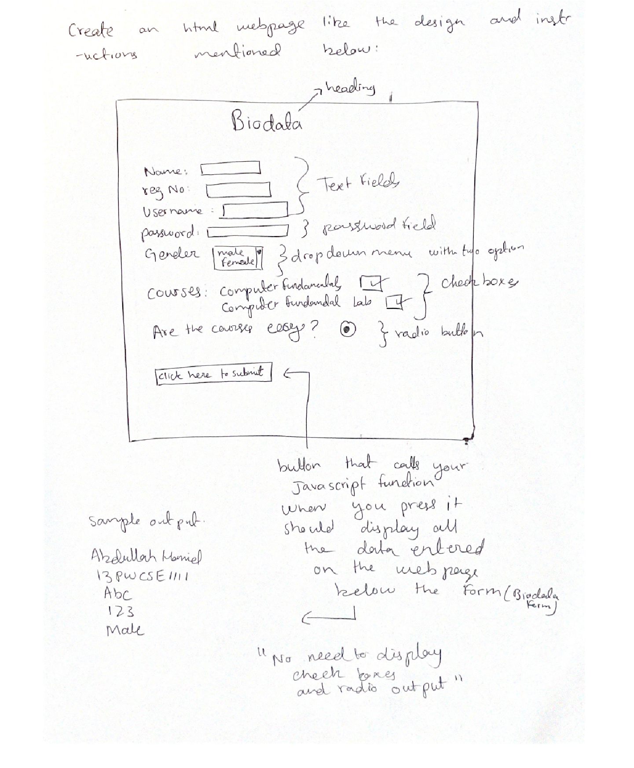

NOTE: Your page must have a background (color or image), also your page font should be courier, font color should be any color matching your background (not black default font color) and everything on the page should aligned to the center, all this should be done through CSS (internal only). Also you must use “CLASS SELECTORS” in CSS.

This Lab task should be uploaded as an HTML FILE. The Picture(s) (if you have used any) should also be uploaded so that I could check it properly.

**HTML OUTPUT**

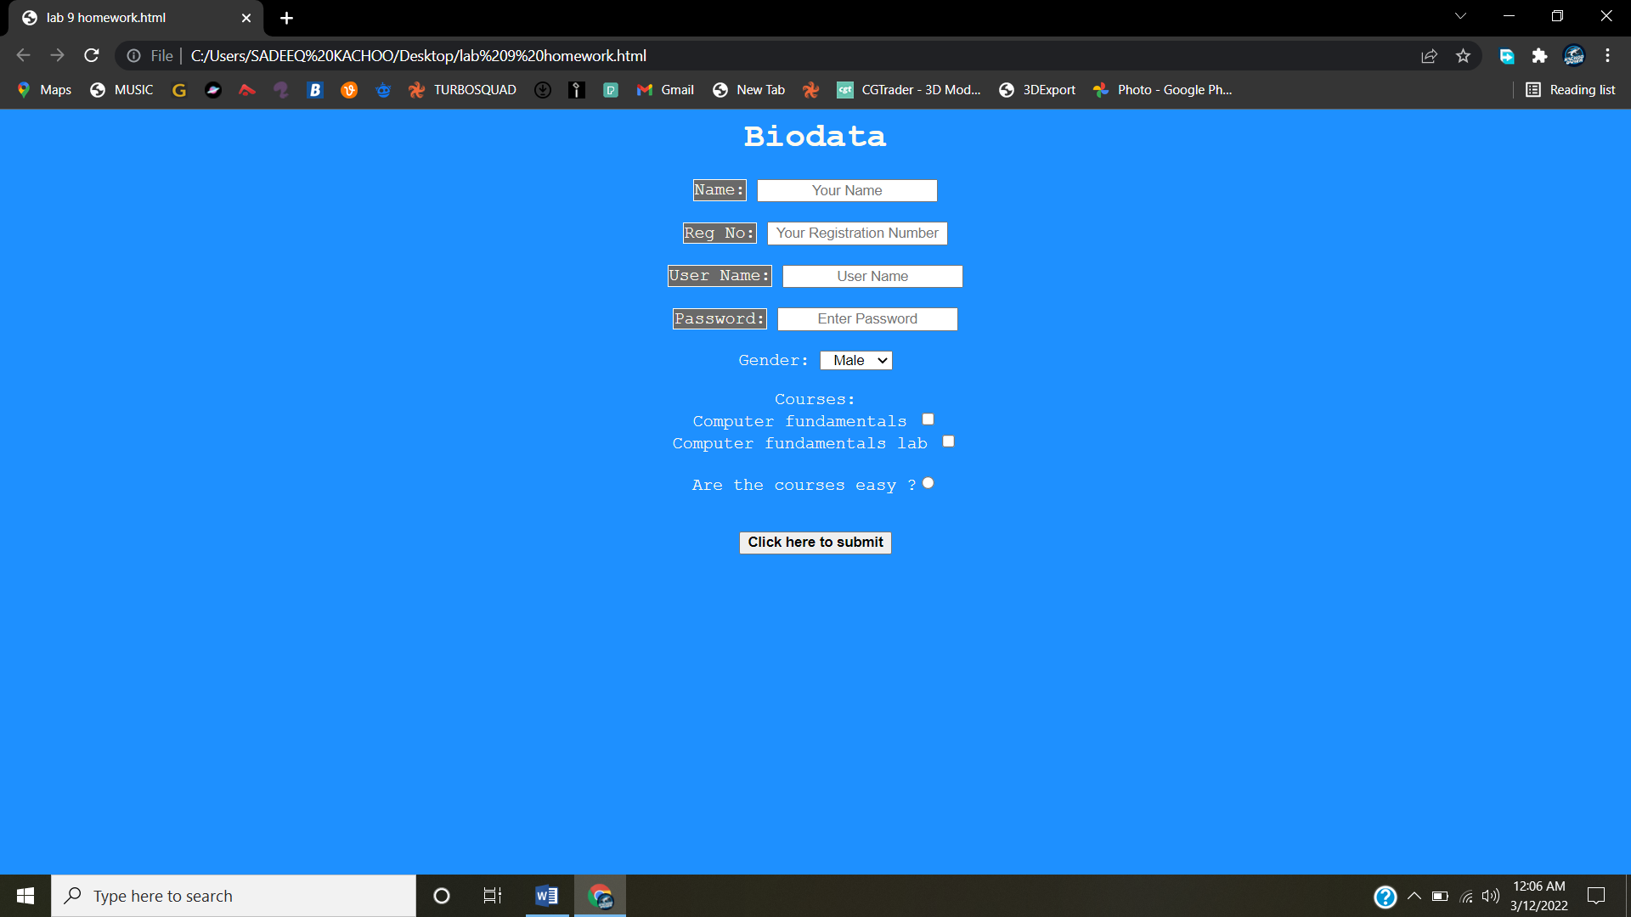

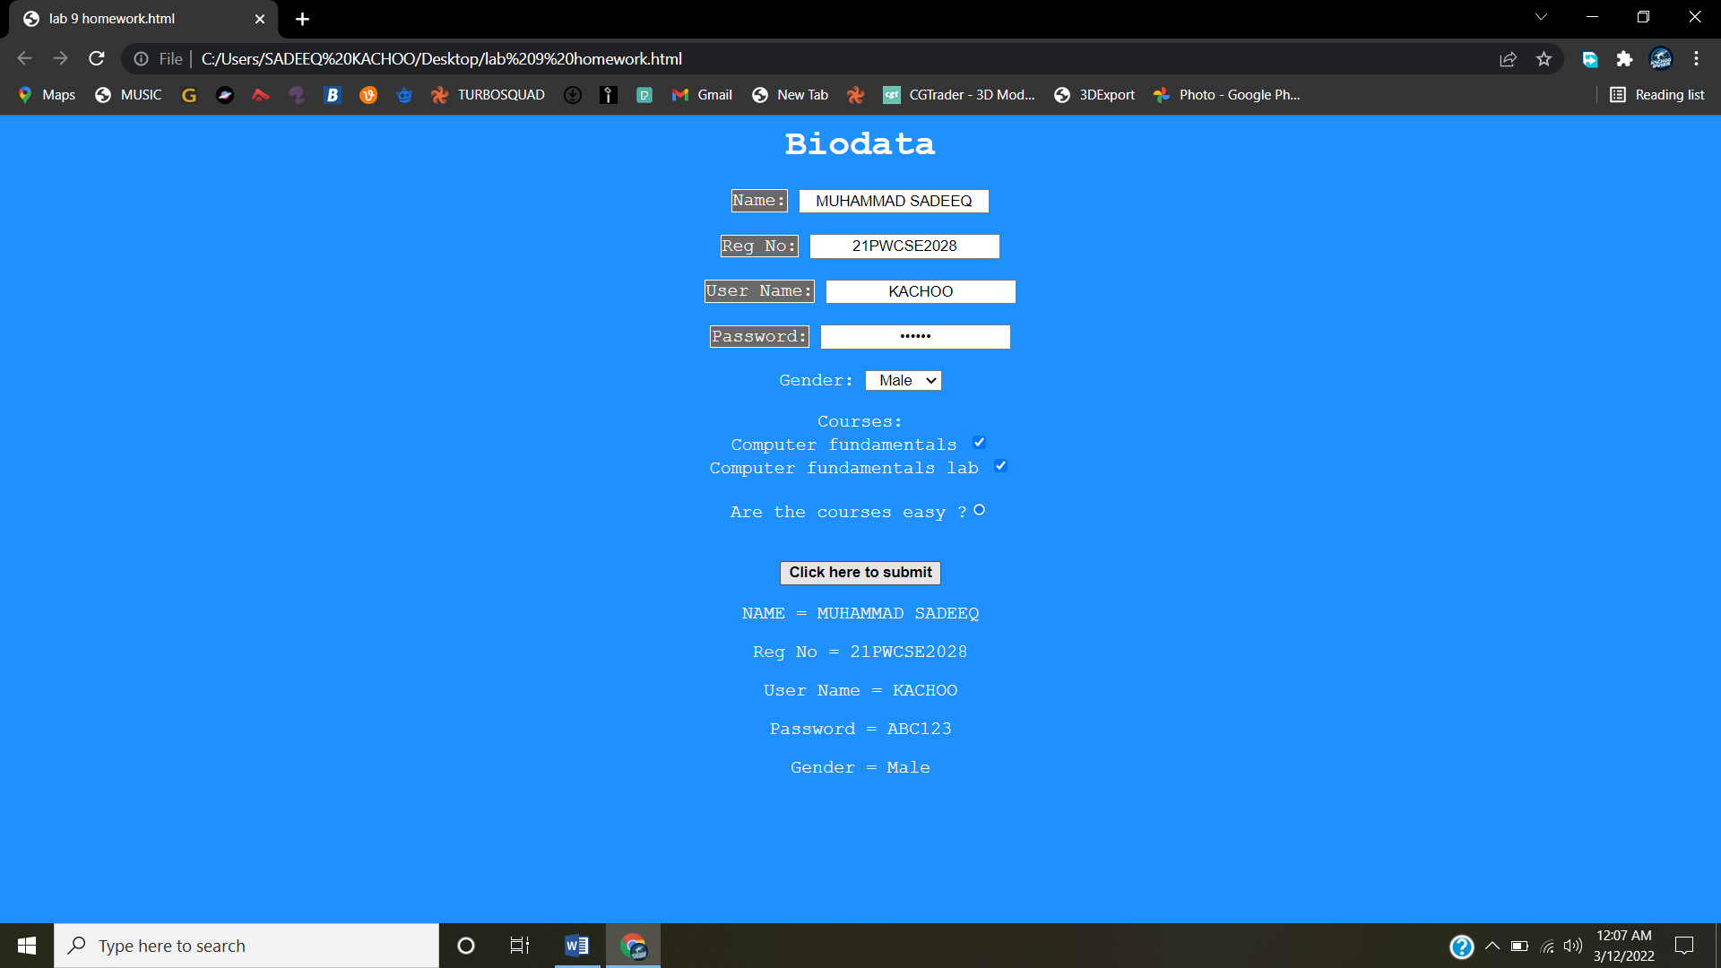

HTML CODE

